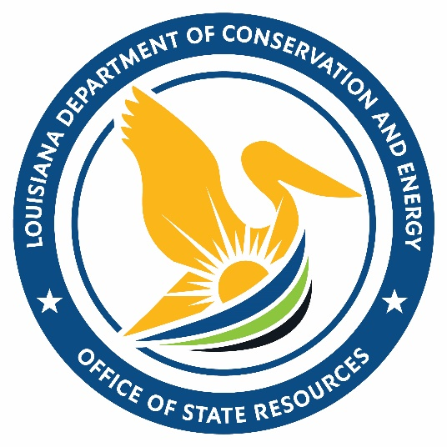
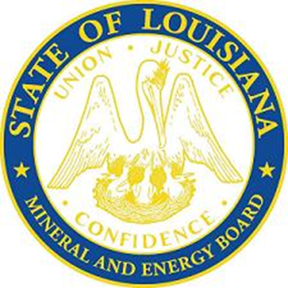

Office of State Resources
Mineral and Energy Board Meeting

October 14, 2026

